Michael Green

ID: fw8109

CSC 4992

Due 1/20/21

**Assignment 01**

**Question 1: Here is a screenshot of my working environment; I have decided to use Visual Studio for Windows. ->**

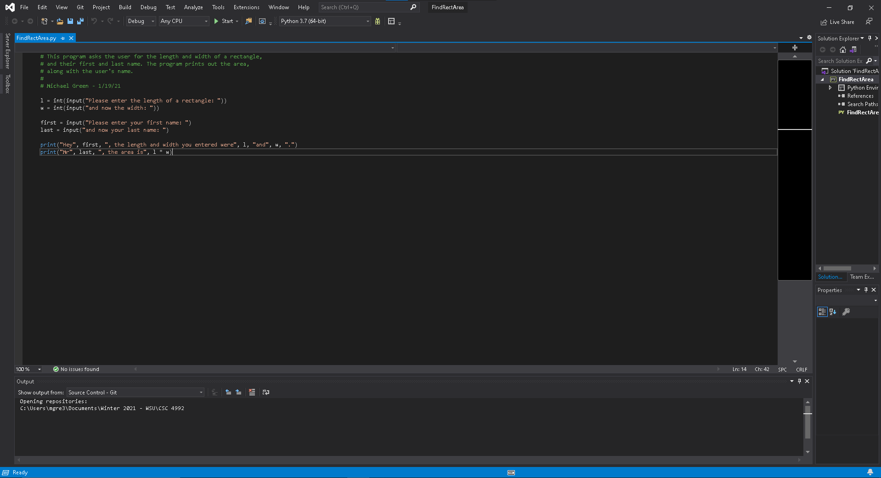

**Question 2: Python is a high-level, general purpose programming language for solving problems on modern computer systems. However, Python is more simplistic and focuses on being easy to read and interpret. The language itself is very intuitive for programmers to learn and use. Python is an interpreted language, meaning that the language is executed as source code through its own virtual machine, known as Python Virtual Machine (PVM). This is similar to Java; however, languages like C++ are compiled languages rather than interpreted languages. Simple expressions and statements can be run in the Python shell. In Python, inputs are Python expressions and statements, and outputs are the results displayed in the shell. This is different from the norm, where inputs come from a source, the program processes the inputs, and outputs results to a destination. Everything runs in the Python shell.**